***Dt : 18/10/2022***

***\*imp***

***3.InnerClasses in Java:***

***=>The process of declaring class inside the class is known as InnerClass***

***or Nested Class.***

***=>These InnerClasses are categorized into two types:***

***(a)Member InnerClasses***

***(b)Anonymous InnerClasses***

***(a)Member InnerClasses:***

***=>The InnerClasses which are declared as members of class are known as***

***Member InnerClasses.***

***=>These member InnerClasses are categorized into two types:***

***(i)Static member InnerClasses***

***(ii)Non-Static member InnerClasses***

***\*imp***

***(i)Static member InnerClasses:***

***=>The member InnerClasses which are declared with "static" keyword are***

***known as Static member InnerClasses or Class member InnerClasses.***

***Coding Rules:***

***(i)Static member InnerClasses can be declared with both static and***

***NonStatic members.***

***(ii)The instance methods in Static member InnerClasses have behaviour like***

***static methods and can access only static members of OuterClass.***

***(iii)Static methods of Static member InnerClasses can access only static***

***members of OuterClass.***

***syntax of creating object for Static member InnerClass:***

***OuterClass_name.InnerClass_name obj = new OuterClass_name.InnerClass_name();***

***Ex:***

***SubClass1.SubClass2 ob2 = new SubClass1.SubClass2();***

***Ex:***

***SubClass1.java***

***package test;***

***public class SubClass1 {***

***public int a=10;//Instance variable***

***public static int b=20;//Static variable***

***public void m1() {***

***System.out.println("****OuterClass m1()****");***

***System.out.println("The value a:"+a);***

***System.out.println("The value b:"+b);***

***}//OuterClass method***

***public static class SubClass2{***

***public void m2() {***

***System.out.println("****InnerClass Instance m2()****");***

***//System.out.println("The value a:"+a);***

***System.out.println("The value b:"+b);***

***}***

***public static void m22() {***

***System.out.println("****InnerClass static m22()****");***

***//System.out.println("The value a:"+a);***

***System.out.println("The value b:"+b);***

***}***

***}//static member InnerClass***

***}//OuterClass***

***DemoInnerClass1.java(MainClass)***

***package maccess;***

***import test.*;***

***public class DemoInnerClass1 {***

***public static void main(String[] args) {***

***SubClass1 ob1 = new SubClass1();//OuterClass object***

***ob1.m1();//OuterClass method_call***

***SubClass1.SubClass2 ob2 = new SubClass1.SubClass2();***

***//static member InnerClass Object***

***ob2.m2();//InnerClass Instance method_call***

***SubClass1.SubClass2.m22();//InnerClass static method_call***

***}***

***}***

***o/p:***

***\*\*\*\*OuterClass m1()\*\*\*\****

***The value a:10***

***The value b:20***

***\*\*\*\*InnerClass Instance m2()\*\*\*\****

***The value b:20***

***\*\*\*\*InnerClass static m22()\*\*\*\****

***The value b:20***

***------------------------------------------------------------------***

***Execution flow of above program:***

***ClassFiles:***

***SubClass1.class***

***DemoInnerClass1.class(MainClass)***

***SubClass1$SubClass2.class***

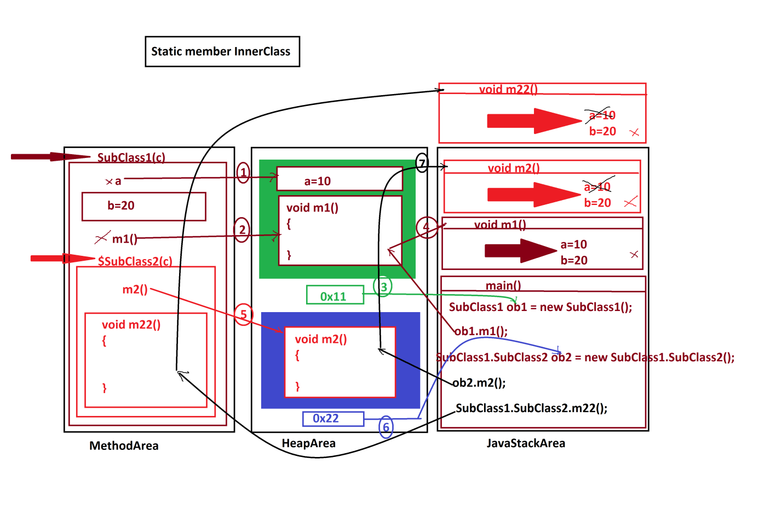

***-------------------------------------------------------------------***

***Note:***

***=>Static member InnerClasses will get the memory within the OuterClass***

***while OuterClass loading.***

***==================================================================***

***(ii)Non-Static member InnerClasses:***

***=>The member InnerClasses which are declared without static keyword***

***are known as NonStatic member InnerClasses.***

***=>These NonStatic member InnerClasses are categorized into two types:***

***1.Instance member InnerClasses***

***2.Local member InnerClasses***

***1.Instance member InnerClasses:***

***=>The NonStatic member InnerClasses which are declared outside the method***

***of OuterClass are known as Instance member InnerClasses.***

***Coding Rules:***

***(i)Instance member InnerClasses can be declared with both static and***

***NonStatic members.***

***(ii)Instance methods of Instance member InnerClasses can access all the***

***members of OuterClass directly***

***(iii)Static methods of Instance member InnerClasses can access only***

***static members of OuterClass directly.***

***syntax of Object creation for Instance member InnerClass:***

***OuterClass_name.InnerClass_name obj =***

***OuterClass_Object_name.new InnerClass_name();***

***Ex:***

***SubClass1.SubClass2 ob2 = ob1.new SubClass2();***

***Ex:***

***SubClass1.java***

***package test;***

***public class SubClass1 {***

***public int a=10;***

***public static int b=20;***

***public void m1() {***

***System.out.println("****OuterClass m1()****");***

***System.out.println("The value a:"+a);***

***System.out.println("The value b:"+b);***

***}//OuterClass method***

***public class SubClass2{***

***public void m2() {***

***System.out.println("****InnerClass Instance m2()****");***

***System.out.println("The value a:"+a);***

***System.out.println("The value b:"+b);***

***}***

***public static void m22() {***

***System.out.println("****InnerClass static m22()****");***

***//System.out.println("The value a:"+a);***

***System.out.println("The value b:"+b);***

***}***

***}//Instance member InnerClass***

***}//OuterClass***

***DemoInnerClass2.java(MainClass)***

***package maccess;***

***import test.*;***

***public class DemoInnerClass2 {***

***public static void main(String[] args) {***

***SubClass1 ob1 = new SubClass1();//OuterClass object***

***ob1.m1();***

***SubClass1.SubClass2 ob2 = ob1.new SubClass2();***

***//Instance member InnerClass object***

***ob2.m2();***

***SubClass1.SubClass2.m22();***

***}***

***}***

***o/p:***

***\*\*\*\*OuterClass m1()\*\*\*\****

***The value a:10***

***The value b:20***

***\*\*\*\*InnerClass Instance m2()\*\*\*\****

***The value a:10***

***The value b:20***

***\*\*\*\*InnerClass static m22()\*\*\*\****

***The value b:20***

***===============================================================***